Ideation Phase
Empathize & Discover

Date | 21 February 2026
Team ID | LTVIP2026TMIDS63602
Project Name | Strategic Product Placement Analysis
Maximum Marks | 4 Marks

Empathy Map Canvas:
An empathy map is a simple, easy-to-digest visual that captures knowledge about a user’s behaviours and attitudes.

It is a useful tool to help teams better understand their users.
Creating an effective solution requires understanding the true problem and the person who is experiencing it. The exercise of creating the map helps participants consider things from the user’s perspective along with his or her goals and challenges.
Example:
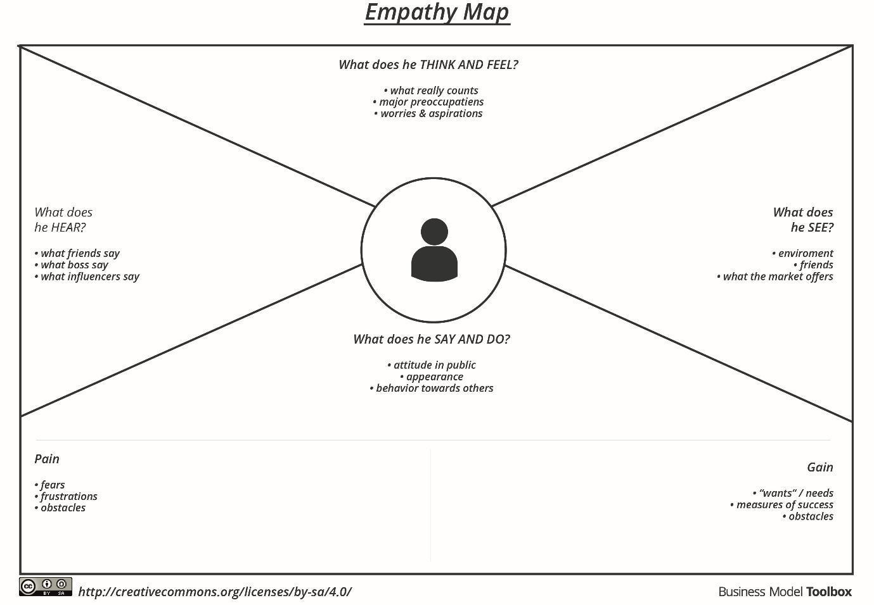

Reference: https://www.mural.co/templates/empathy-map-canvas

Example: Resolve Now
🧠 User: Business Owner
SAYS | THINKS | DOES | FEELS
I want to understand which product category generates the highest sales. | Which product category performs best? | Reviews dashboard and analyzes sales visualizations | Curious, decision-focused
I need insights to improve product placement. | Which placement location improves sales performance? | Checks dashboard filters and placement analysis | Motivated to optimize sales strategy
I want clear visual insights to make decisions. | Interactive dashboards will help analysis. | Uses Tableau dashboards and stories | Confident and informed

🧠 User: Store Manager
SAYS | THINKS | DOES | FEELS
I want to place products in optimal locations. | Which placement position generates higher sales? | Analyzes placement performance using dashboard | Responsible and analytical
I need better insights to improve store layout. | Sales data needs clear visualization. | Uses interactive dashboard tools | Confident and strategic

🧠 User: Data Analyst
SAYS | THINKS | DOES | FEELS
I want to analyze sales trends effectively. | How can I present insights clearly? | Creates and analyzes Tableau visualizations | Focused and productive
Interactive dashboards improve analysis. | Traditional reports are inefficient. | Uses Tableau dashboards and stories | Confident and satisfied
